Lab 1: Brandon Kowal, Bernard Owusu Sefah

54645D Analog Channel Lab

Abstract

The purpose of the lab was to introduce the HP-54645D MSO and the ETS-7000 Digital Training System. The protocol for this lab was to follow every tutorial to learn about the basic triggers and buttons. Two circuits were made one to familiarize the breadboard and the other was a 7404 Hex Inverter IC. The IC had 14 pinouts and the 7th pin was a ground and the 14th pin the Vcc (power supply).

Introduction

This lab is to introduce the safety procedures, equipment at the lab station, and showing tutorials for the basic experimentation procedure in the laboratory. The lab aims to help better understand the functionality of the prototyping breadboard and the ETS-7000 Digital Training System, HP-54645D Mixed-Signal Oscilloscope (MSO), and a SN7404 HEX Inverter: a basic logic gate. The controls on the 5464D are grouped into sections: Analog Channel inputs, Horizontal measurement, Trigger, Storage and Digital Channel inputs.

Methods

The protocol for this lab was followed as described in the *54645D Analog Channel Tutorial* paper. We went through every tutorial to learn about the basic triggers and buttons on the 54645D Mixed Signal Oscilloscope. We had to turn on the 54645D by pressing the Line button near the lower right corner of the display and then followed each step on the tutorial to learn more about what each trigger does. For example, the A1 key which adjust the settings so that channel 1 is on.

In using the ETS 7000 trainer protoboard we had connected couple of wires and probes onto the breadboard of the ETS 7000;

1. Connect a wire to the ground terminal on the ETS 7000 and then onto the breadboard.
2. Connect the probes of both analog channels A1 and A2 to the 54645D Mixed Oscilloscope.
3. Connect two wires to the probes of the digital channels D0 and D1 of the HP 54645D MSO and then onto the breadboard.
4. On the front panel of the ETS 7000 select the square wave form and set the frequency of the signal to 1KHz.
5. Set the amplitude knob to max position and turn on the ETS 7000 to display the results.

In using the 7404

Hex Inverter IC we had to,

1. Select the square waveform and se the frequency of the signal to 1KHz.
2. Insert the 7404 Hex Inverter onto the breadboard of the ETS 7000 and connect the GND and Vcc pins of the 7404 IC to the corresponding ground terminals and +5V onto the breadboard of the ETS 7000.
3. Identify the pins of the inverter of the IC and connect the TTL mode input to the TTL input on the ETS 7000 and then connect the output mode onto the output of the inverter gate.
4. Connect the input pin of probe A1 to the inverter gate and connect the output pin of probe A2 to the inverter.
5. Connect the input pin of digital channel D0 of the MSO to the input mode of the inverter and then connect the output pin of the digital channel D1 into the output of the inverter gate.
6. Finally set the threshold of the digital channels to TTL, then set the triggering mode to normal and press the single key.

Results

The results of the lab were displayed onto the HP-54645D MSO and was then captured using a computer. Captured results are below.

Fig 1. Square wave

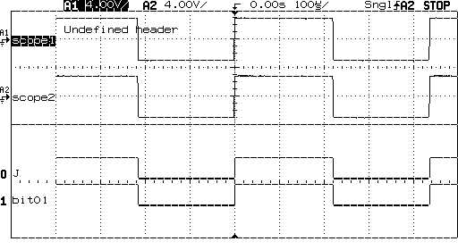

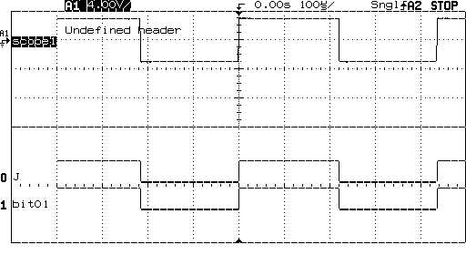

Fig 2. Sinusoidal wave

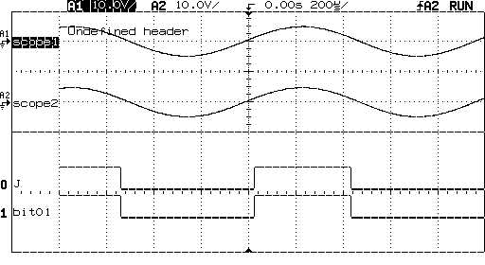

Fig 3. Triangle wave

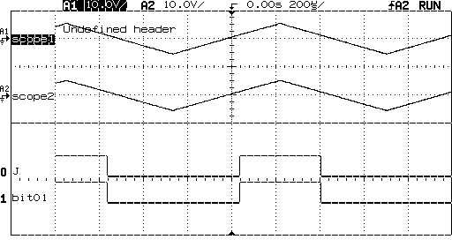

Figure 4. Logic Gate Square wave

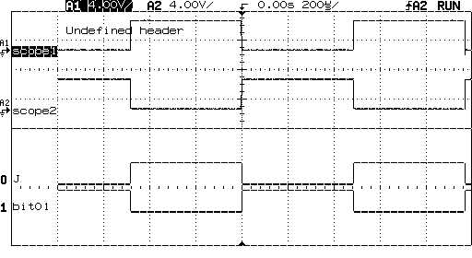

Discussion

During the Lab the 7404 IC device was used. The IC had fourteen pinouts and every two was an input than an output, those are NOT gates and they are six of them. The 7th pin is the ground and the 14th pin is the Vcc. When wiring the 7404 Hex Inverter IC there were problems understanding which ones had to be put in the input and which ones need to be in the output.

Also, the lab showed us what we need to make the circuit, but we still had some trouble figuring out where the placements of each wire should be.

Conclusion

This lab gave a better understanding of how to use an ETS-7000 Digital Training System and how to use a HP-54645D Mixed-Signal Oscilloscope and a SN7404 HEX Inverter: a basic logic gate. The lab helped understand how the IC device had the gates that had an input and an output with the 7th pin being a ground and the 14th pin being a Vcc.

Appendix

Lab Attendance: Bernard Owusu Sefah: Yes Brandon Kowal: Yes

Involvement in Lab: Bernard Owusu Sefah: 55 Brandon Kowal: 45

Involvement in Lab Report: Bernard Owusu Sefah: 60 Brandon Kowal: 40

References

“Control 7404, NOT Gate IC, Using Switch.” *Arduino Program to Design Running Diagonal LEDs in an 8*8 LED Matrix «*, [www.learnerswings.com/2014/07/control-7404-not-gate-ic-using-switch.html](http://www.learnerswings.com/2014/07/control-7404-not-gate-ic-using-switch.html).